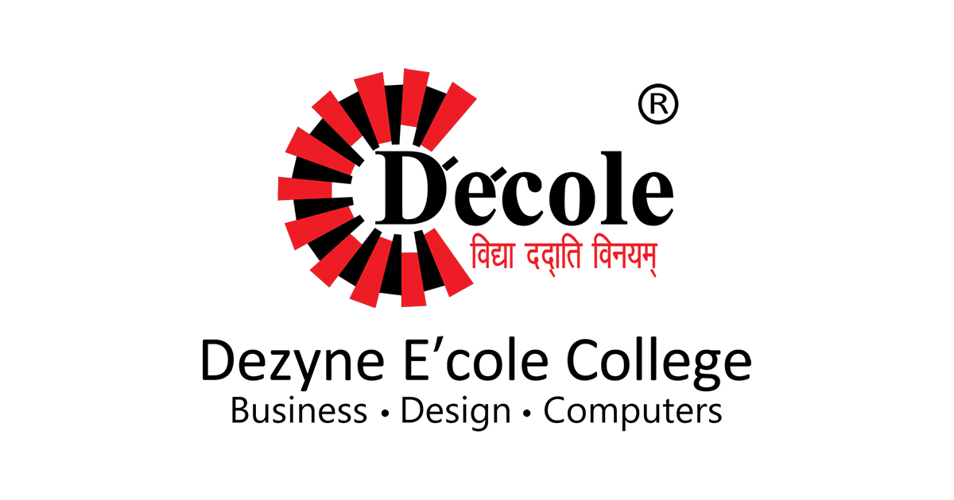
Hackthon Identity 2026
Project – Ajmer Goes live
Topic – Vyas Associate
Submitted by :- Krishna Vyas
BCA Batch – B

PROCESS SHEET
1. Client Details
- Business Name – Vyas Associates
- Business Type - Crusher Spare Parts
- Director’s Name – Mr. Vikas Vyas
- Website Purpose: To provide information about the crusher parts, its items facility, faculty, and contact details.
- Client Requirements:
  - Information about the crusher parts.
  - Knowledge about different parts .
  - Faculty details.
  - Contact information.
  - Order & enquiry details.

2. 5 questions you asked and their answers
Question 1: What is the main reason you want this website?
Answer-We want an online identity for Vyas Associates . It will make it easy for Clients to check about our Business.
Question 2: What pages and information do you want on the website?
Answer-The website should clearly show an introduction about our Business, In Which We make concaves, mantles, jaw plates, rollers and other wear parts for crushing, screening and conveying equipment, and we inspect, machine and test every part in our own facility.

Question 3: How do you want Clients to contact you through the website?
Answer-We need our phone number and address listed clearly, along with a simple enquiry section where Clients can check for Order’s details or message us through whatsApp link.
Question 4: Do you have a logo or any specific colour preference for the design?
Answer-We will share our official logo with you. For colours, we prefer something professional and educational, like blue and white, which looks clean.
Question 5: Do you want to show the Rate Amount structure of the Crusher Parts on the website?
Answer- No, we don't want to put exact Amount Structure online because they change based on regular Bases .

3. Sitemap

- Cone Crusher Parts
- Jaw Crusher Parts
- Rollers, mesh & wear rings

- Our Story
- What We Do
- What We Stand For

- About Crusher Spare Parts
About Page
- Get In Touch
- Find Us
- Opening Hours
Contact Us
Product / Facility
HOME PAGE
Sitemap Of My Crusher Parts Website
4. Hand-drawn Wireframing

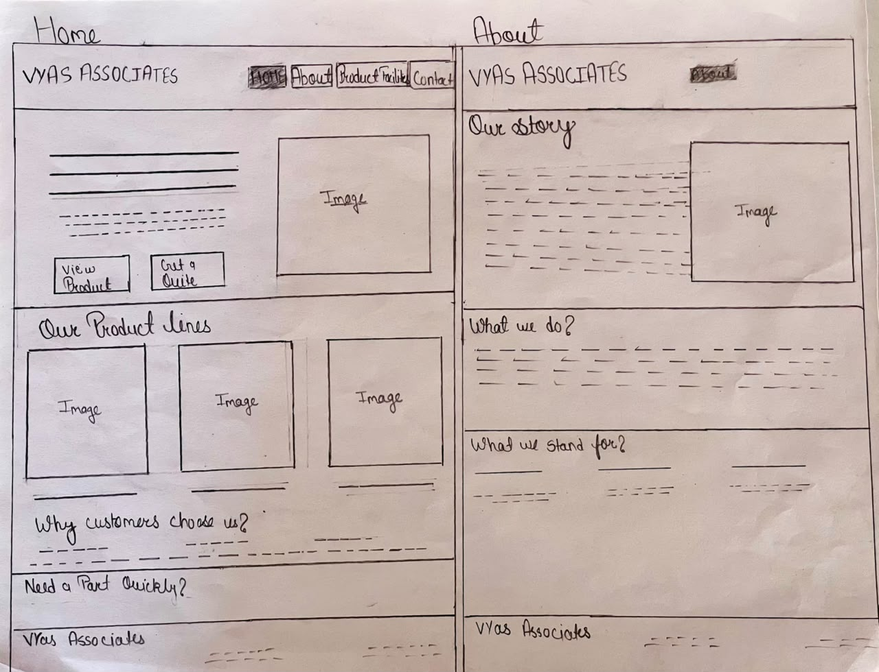

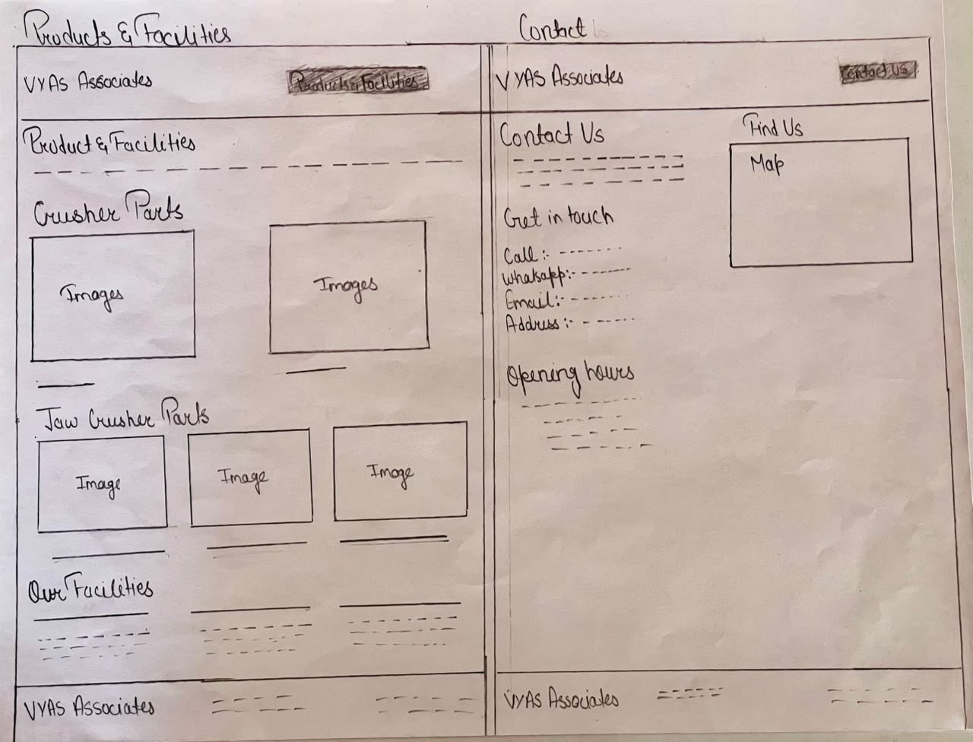

5. Reason for choosing colour and font style
1. Reason for Choosing the Color Combo (Blue and White)
- Direct Alignment with Heavy Industry: Deep charcoal/slate paired with vibrant rust-orange immediately evokes heavy machinery, mining, and quarry equipment (reminiscent of safety gear and brands like Caterpillar or Komatsu). Orange is universally associated with construction, high durability, and industrial safety.

- Maximum CTA Visibility: The warm, high-energy orange creates strong visual contrast against the dark background. This guides the user's eye directly to key conversion targets—specifically the primary call-to-action button ("View products") and the active navigation tab.

- Modern & Rugged Aesthetic: Rather than using a generic corporate white background, the deep slate dark mode gives the interface a solid, heavy-duty feel that reflects the strength and longevity of wear parts like concaves and jaw plates.

- Palette Harmony with Photography: The warm orange accents seamlessly mirror the yellow-orange tones of the industrial crushing plant in your imagery, giving the entire interface visual balance and cohesion.
2. Reason for Choosing Font Style (Arial, Helvetica, sans-serif)
- Industrial Strength & Solid Presence
- High Contrast & Screen Legibility:
- Clear Visual Hierarchy
- Modern B2B Standar

6. Validator And Lighthouse Screenshots
- Home Page
Validator :-
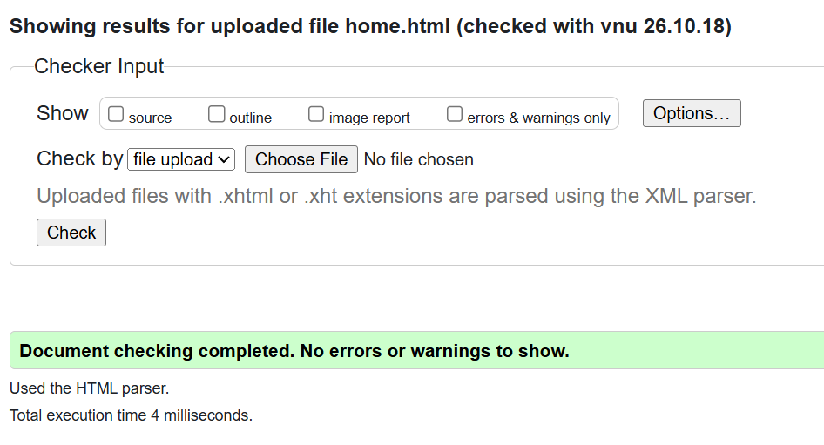

Lighthouse :-
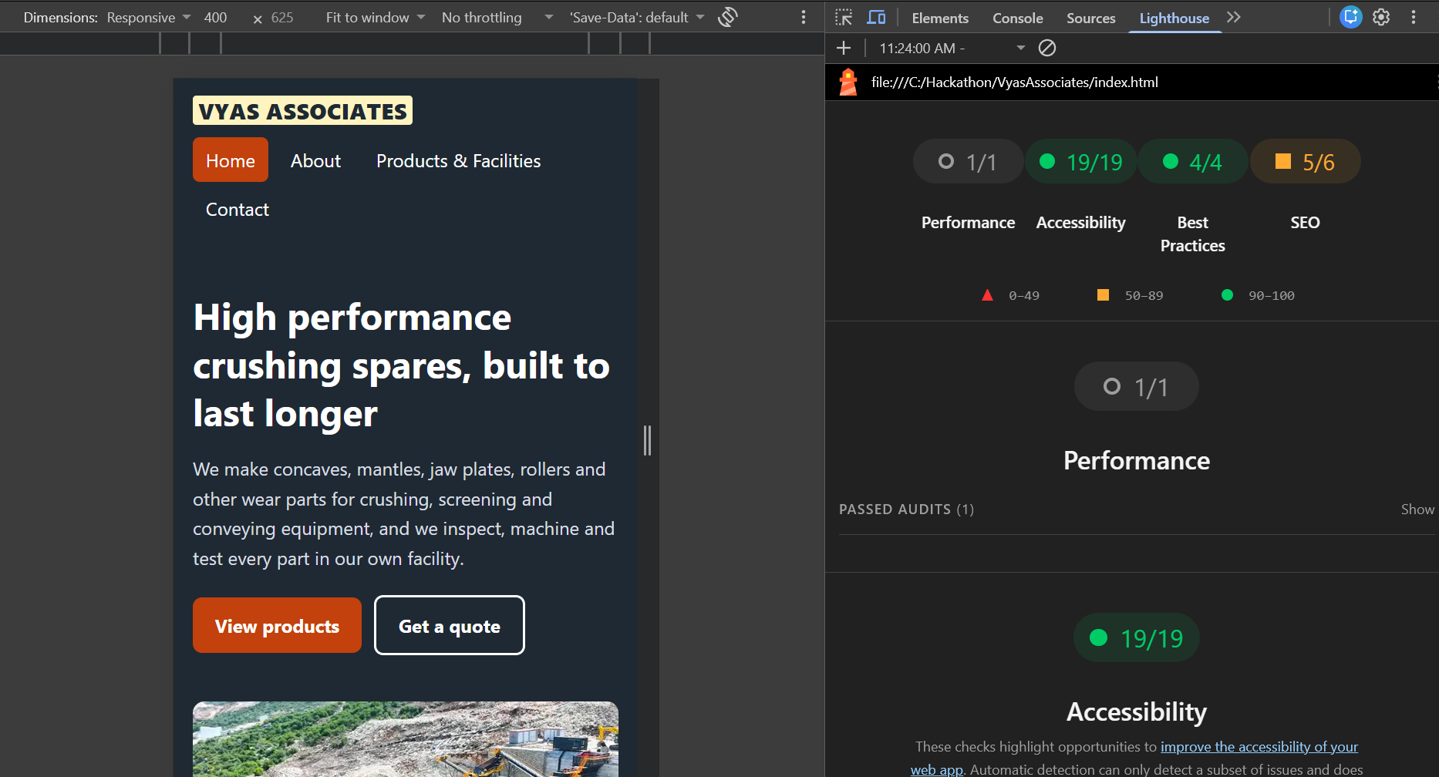

- About Page
Validator :-
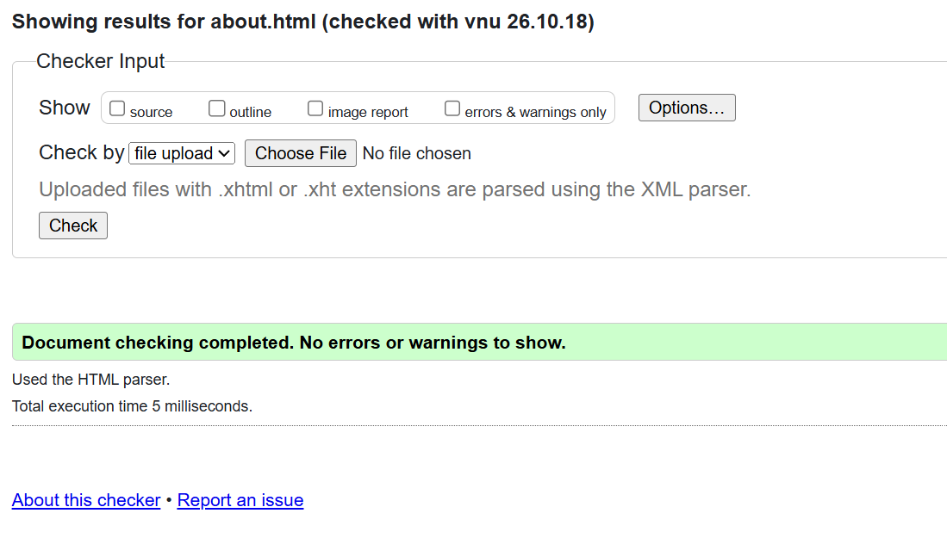

Lighthouse :-
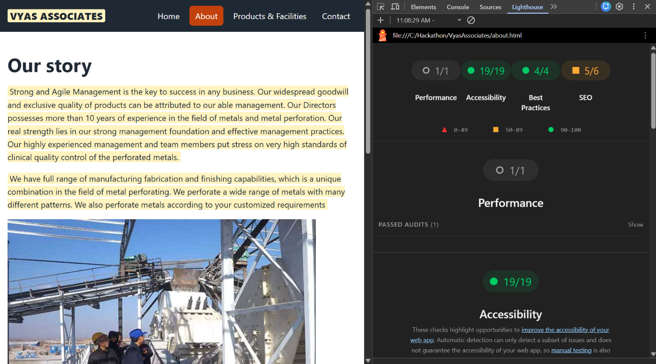

- Products & Facilities
Validator :-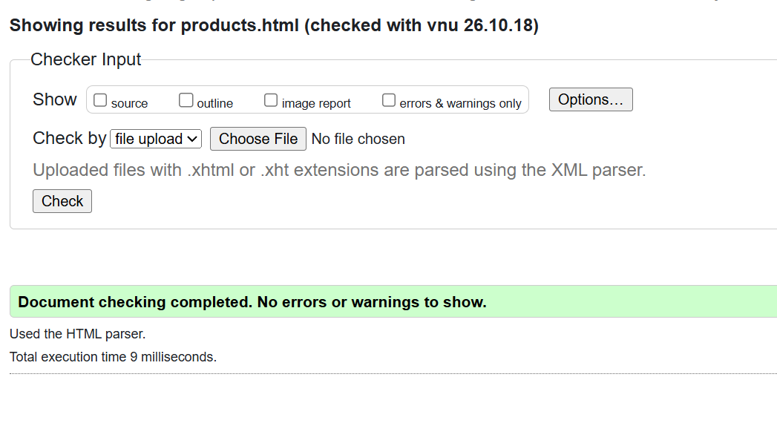
Lighthouse :-
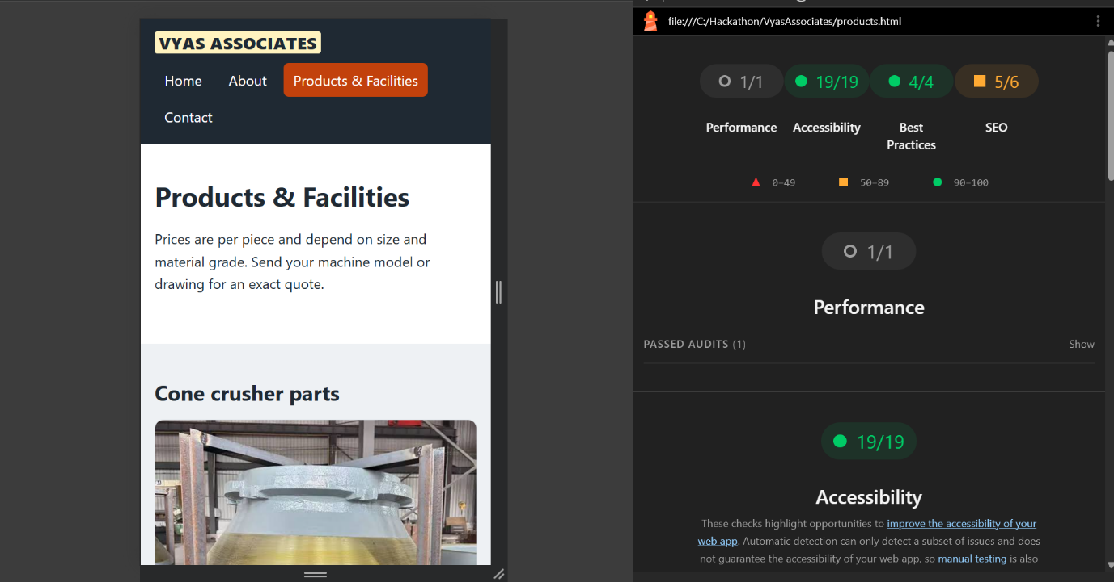

- Contact Us
Validator :-
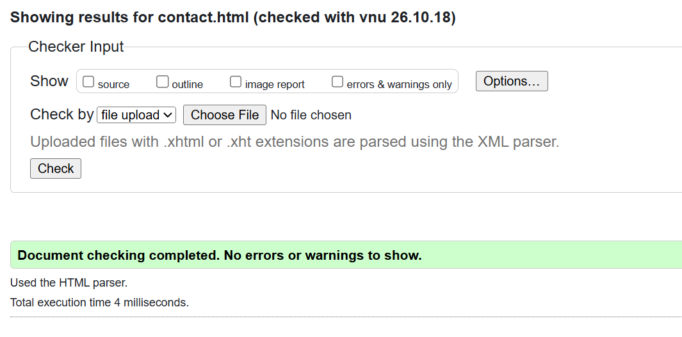
Lighthouse :-
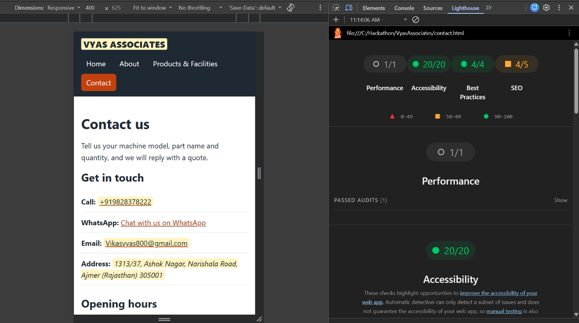

- STYLE SECTION
Validator :-
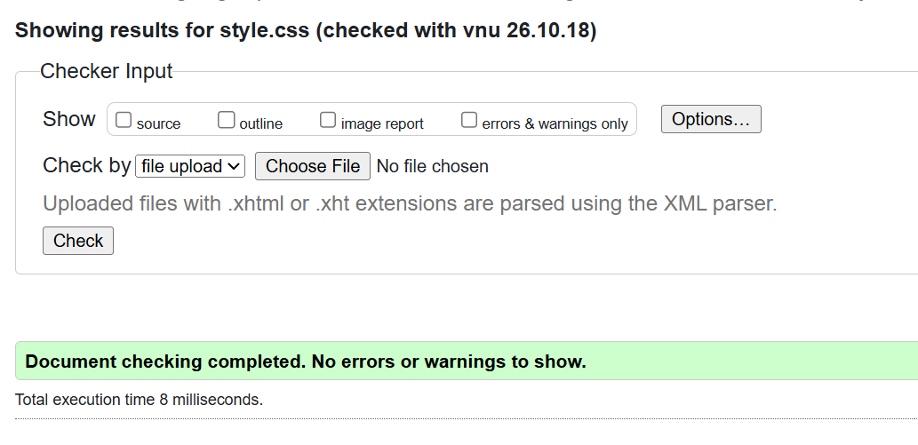

Approval By Client:-

